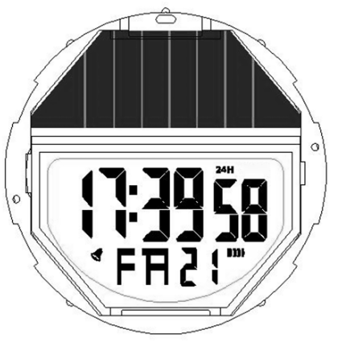

LIGHT（A K ey）
（ D Key） START

（C Key） RESET
LMODE（B Key）

A . Features
- 10 Digits LCD Display , Display Hour ,Minute ,Second ,Date and week.
- Daily Alarm and Chime hourly
- 12 / 24H format selectable
- 1/100 second Chronograph with split functions
- EL backlight
- Without sun or light , the watch power come from the battery.
- In the sun or light source , the solar panel can accept solar / light power , and supply it to the watch for work , no need battery power.

B . Operational Manual
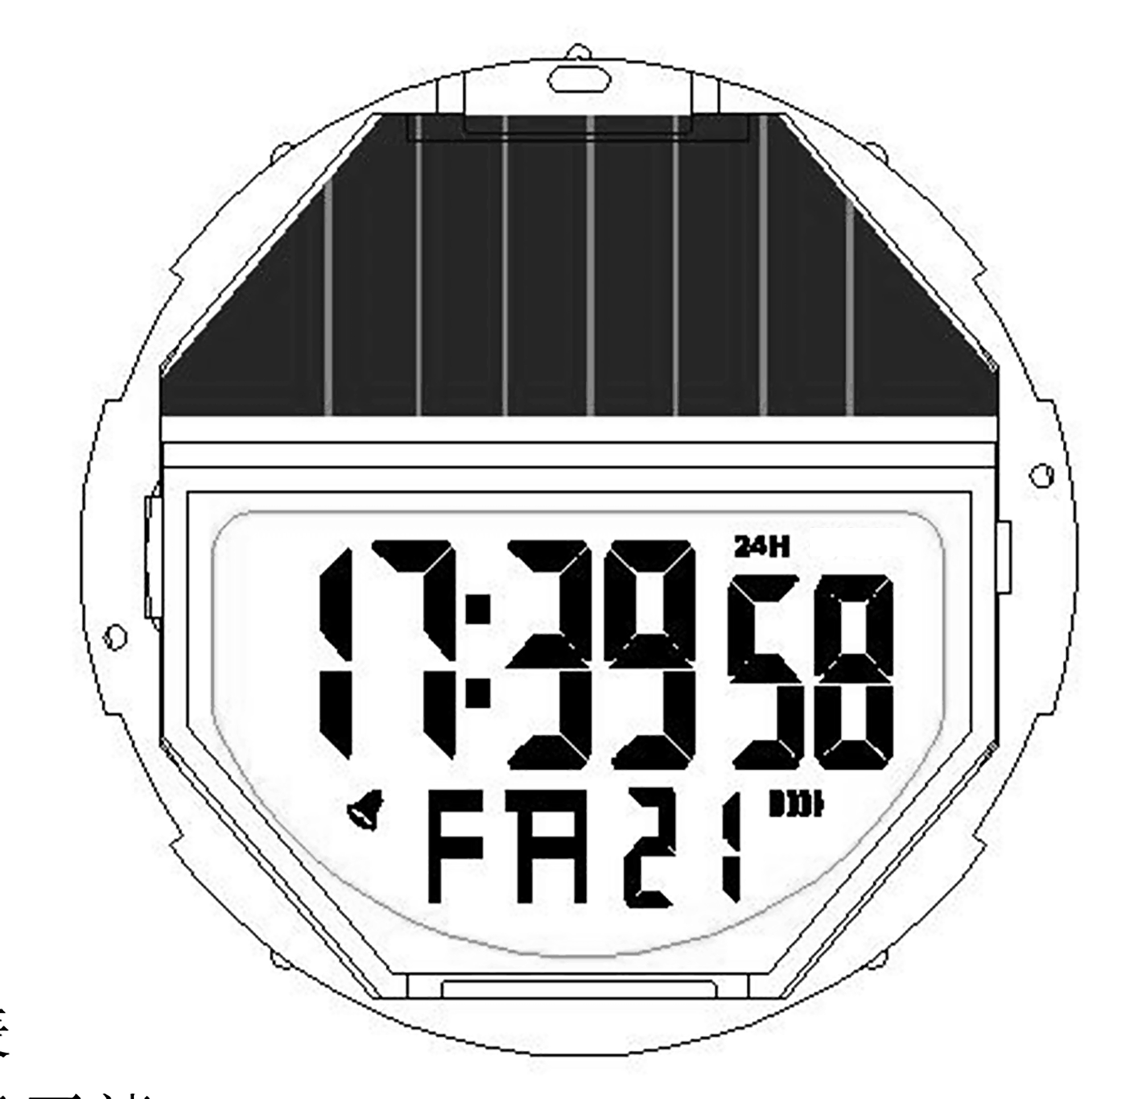
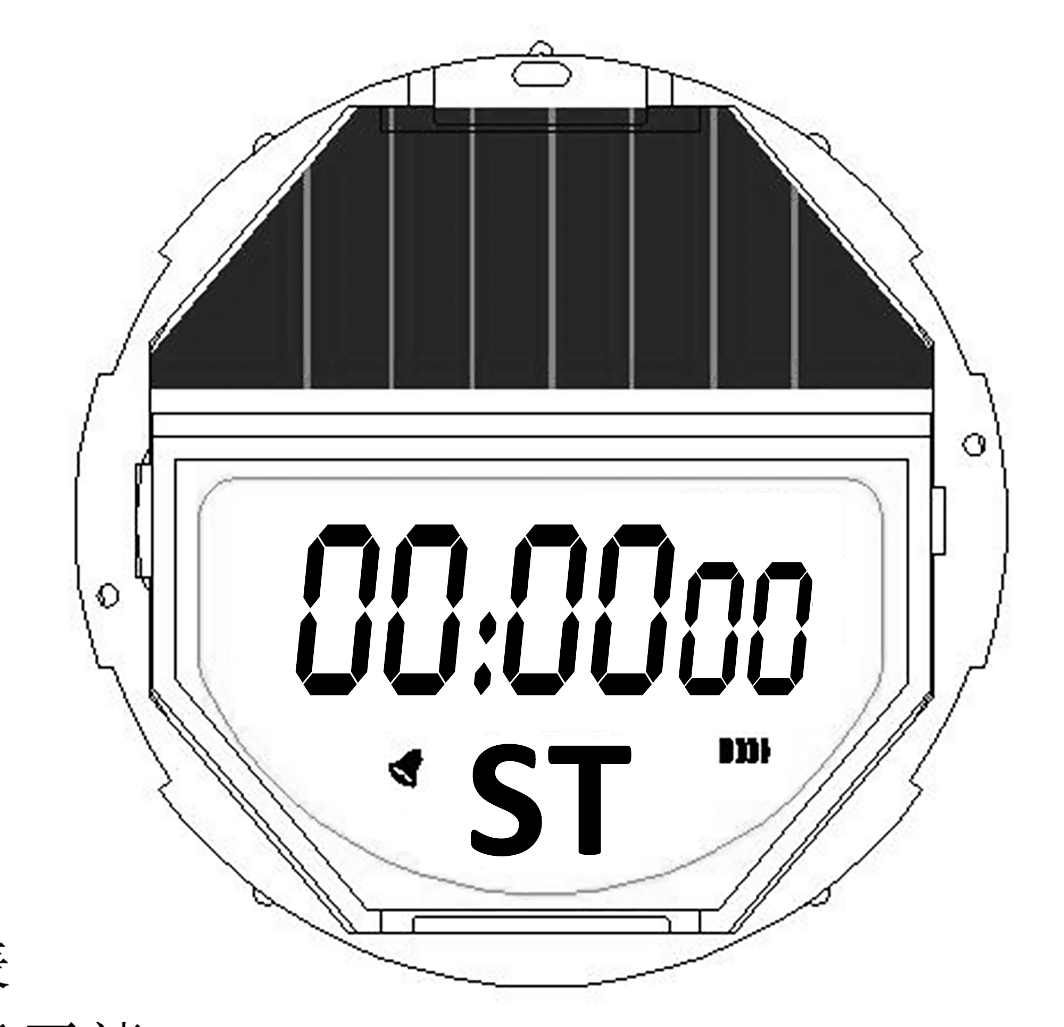
B Key
B Key
B Key
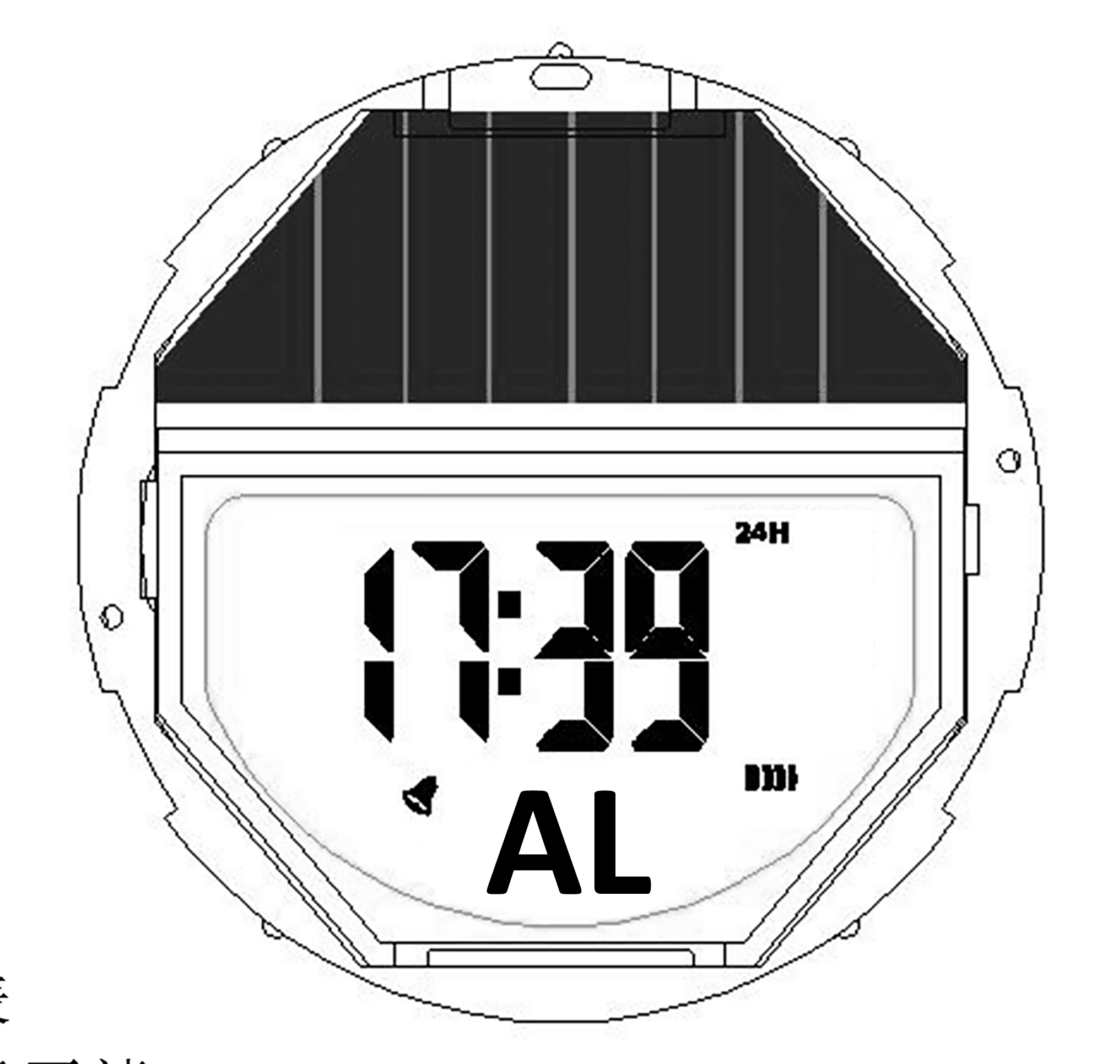

Chronograph
Alarm
Time setting
Real Time

- Real Time
- Press D key to convert 12/24 time, the screen shows "24H" when it is the 24 hour mode.

- Daily Alarm
- Turn On / Off Alarm and Chime: In Alarm mode ("Hour" and "Minute" do not flashing), press D key to turn on/off the Alarm :( ) and Chime: ( ) in turn.
- The Alarm opening sign ( ) and the Chime opening sign ( ) are displayed in all function modes.
- Whatever function mode is currently displayed, the Alarm will ring for 20 seconds when it reaches the preset time and the Alarm sign ( ) will flash during the Alarm.
- After turning on the Chime, sound ( BI BI )will be issued at every Chime hour.
- Alarm setting : Press C key to select "Hour " or "Minute "setting, Press D key to adjust the flashing item, Press C key to confirm, Press B key to return to Real Time mode.

- Chronograph
- The display range of the Chronograph is 59 minutes, 59.99 seconds.
- If the Chronograph is not stopped, even if the Chronograph function is exited, the test time will continue.
- If the Chronograph function is withdrawn, the halfway time will be cleared and the picture will return to the time-lapse measurement screen when the halfway time is displayed in the screen.
- Press D key to Start/Stop running.
- When stop, press C key to zero.
- When running , press C key to split count .
- When press D key to exit split count .
- Press C key to Chronograph, that is to record the completion time of the first player.
- Then press D key to complete the measurement, record the completion time of the second players and finally press C key to clear the record.

- Time Setting
- “Second " flashing when loading ,press D key to zero ; Press C key to select item as following sequence : Minute, Month, Day, Week.
- When running, press B key to return to Real Time Mode.

C. Specifications
：Ф36.20mm
：8.7mm
：-10℃~60℃
：3.0V
：±45sec/month
：CR2032(capacitance: 220m Ah)
：≤2.02u A (static maximum current ：3.5uA)
：≤0.98m A （Alarm maximum current ：3.5mA）
：≤7.41m A （ELlighten maximum current ：10.0mA）
：≥48 month(Japan Lithium)
- Module Size
- Module Thickness（include buzzer）
- Operational Temperature Range
- Operational Voltage
- Accuracy
- Battery Code
- static average current
- Alarm average current
- EL lighten average current
- Battery life

Under the following conditions:( 4 backlight operation ( 3 seconds) perday; 60 seconds of alarm operation per day)

