**USER MANUAL**

**Display and Button Functions**

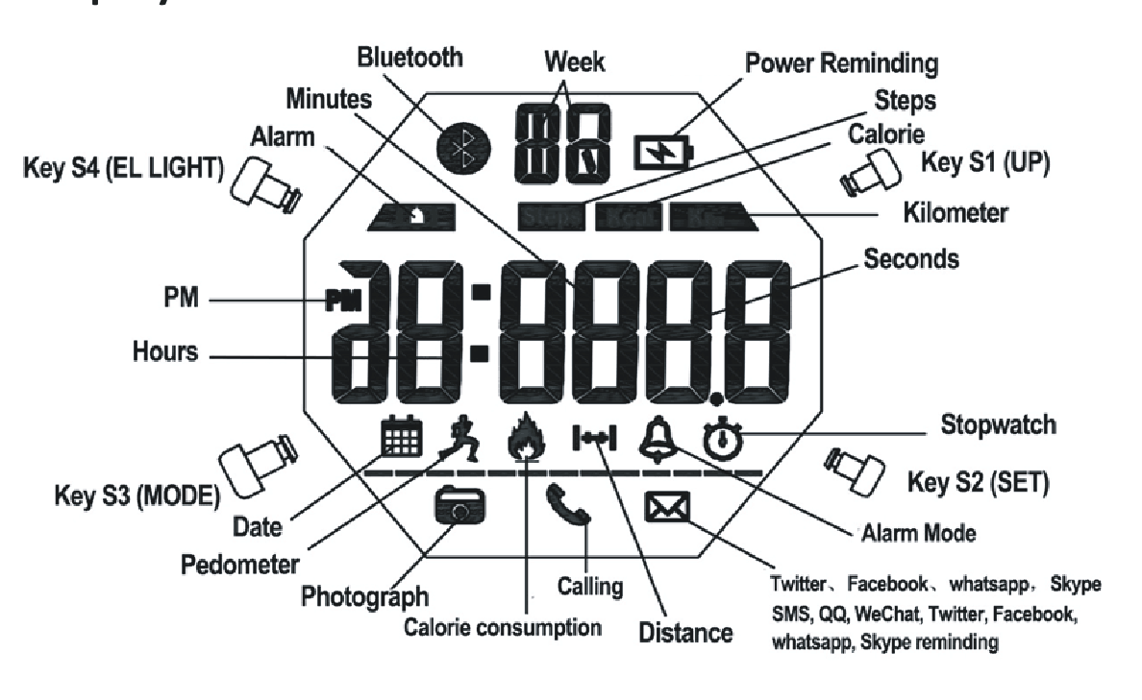

**Key S1 :** Up ,Begin timing ,Pause,Switch,Photograph

**Key S2 :** Selection,Setting,Reset

**Key S3 :** Mode Conversion,Confirming and Save

**Key S4 :** EL Back Light, Bluetooth Switch

**Function instruction:**

**1.** 8-digit timer function, the normal time mode display Week,Hours,Minutes, seconds

(Synchronize automatically with your phone when connected with the phone)

**2.** 12/24 hour Format setting selection (Synchronize automatically with your phone when connected with the phone)

**3.**24 hours precise 3D pedometer / calorie consumption / distance detection (the data can be uploaded to the phone when connected with the phone )

**4.** Alarm:Timing Alarm( The alarm time can be set by the APP when connected with phone.)

**5.** Stopwatch/Chronograph: Maximum stopwatch timing 23 hours, 59 minutes and 59 seconds, can be split

**6.** EL backlight, press Key S4 one time the light will last 2 seconds.

**7.** Low Battery Power Reminding (the icon flashes when voltage of the battery is under 2.4V)

**8.** The Bluetooth function can be turned on and off (different application mode to save power)

**9.** To share and rank the sport data in circle of friends with Chinese or English APP in Android/IOS phone,support global network by backstage server.

**10.** When connecting with APP of phone or Tablet PC,it can upload sport data and backup to the cloud server

**11.** Synchronize the time, date and alarm setting smartly in your phone, instead of the cumbersome manual operations.

**12.** Reminding of Calls, SMS, QQ, WeChat, Twitter, Facebook,Whatsapp and Skype.

**13.** Taking Photo from Phone Camera by remote control

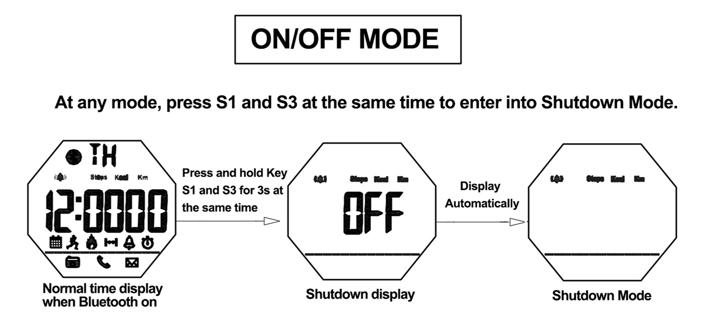

**In shutdown mode, press and hold Key S1 and S3 for 3s at the same time to**

**enter into boot mode.**

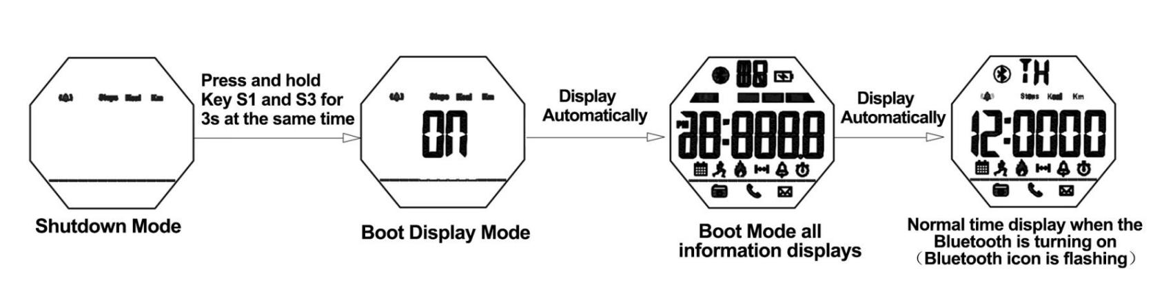

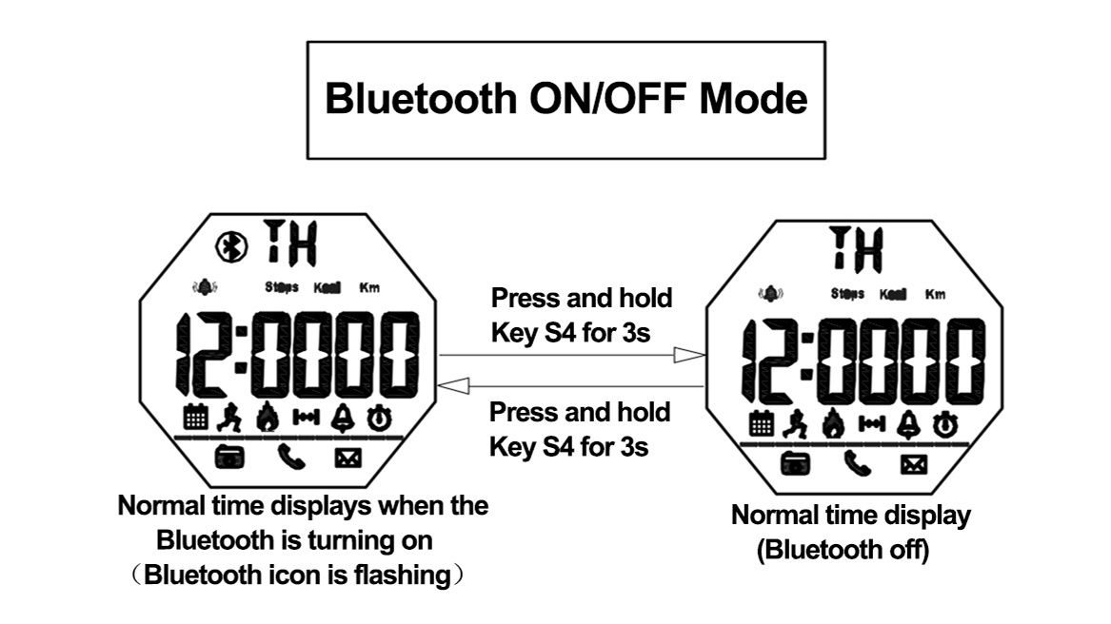

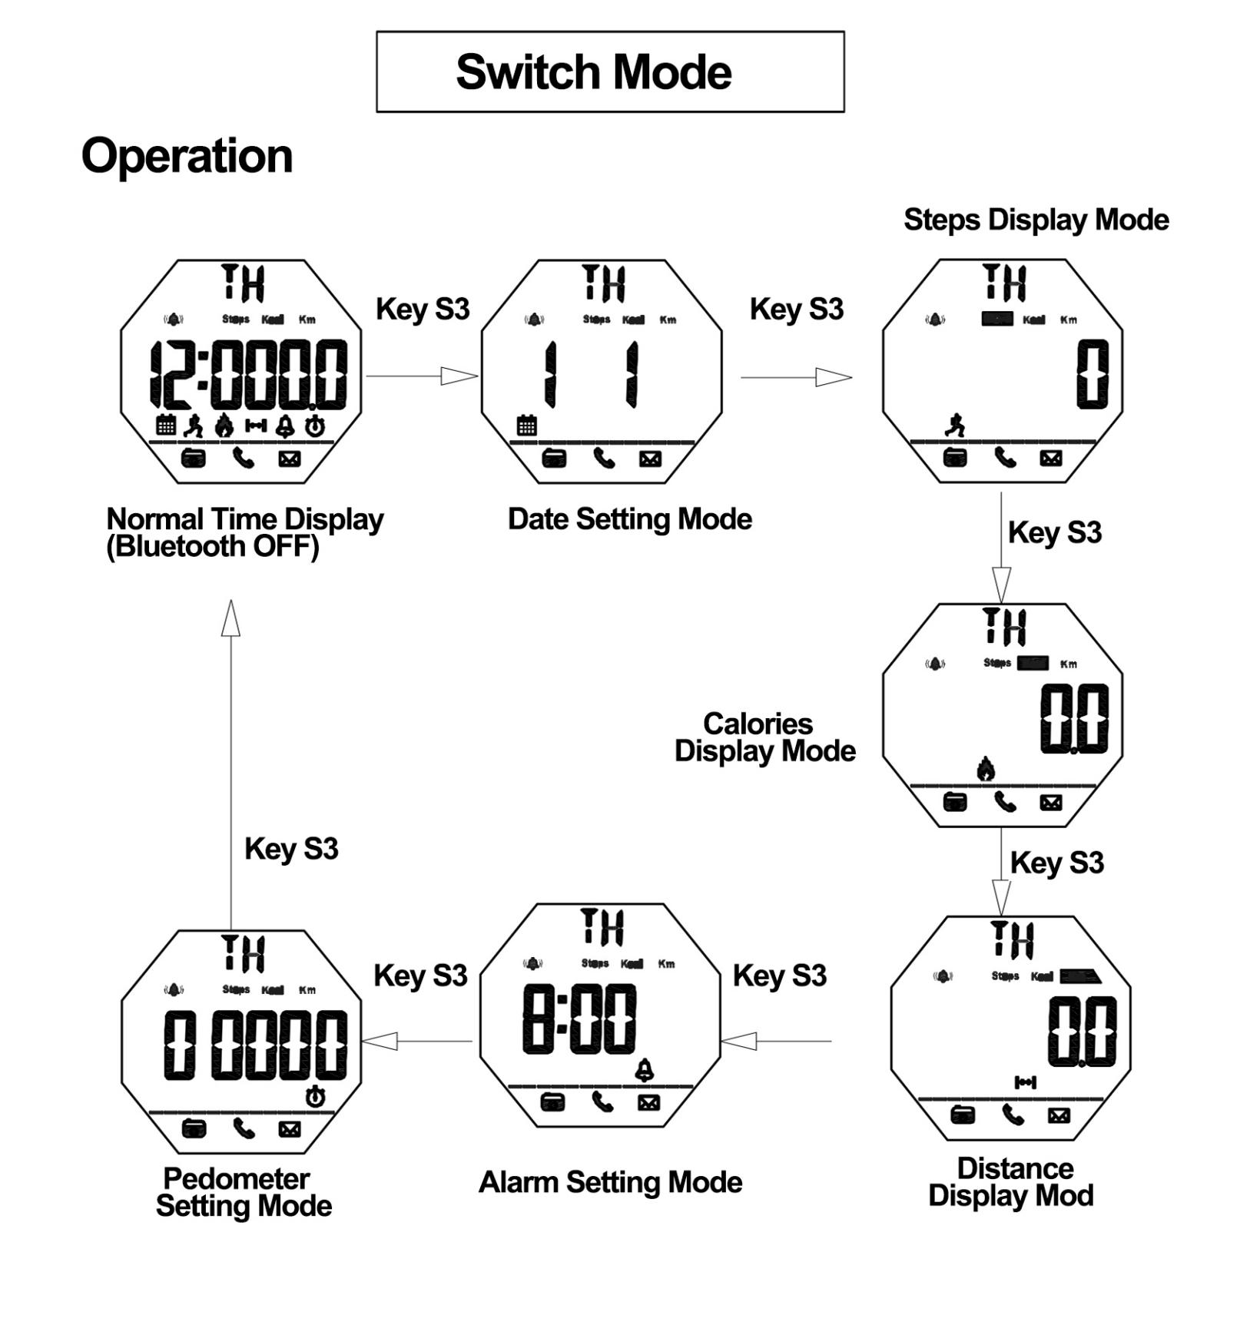



**At any mode, press S4 once, the EL back light on for 2 seconds.**

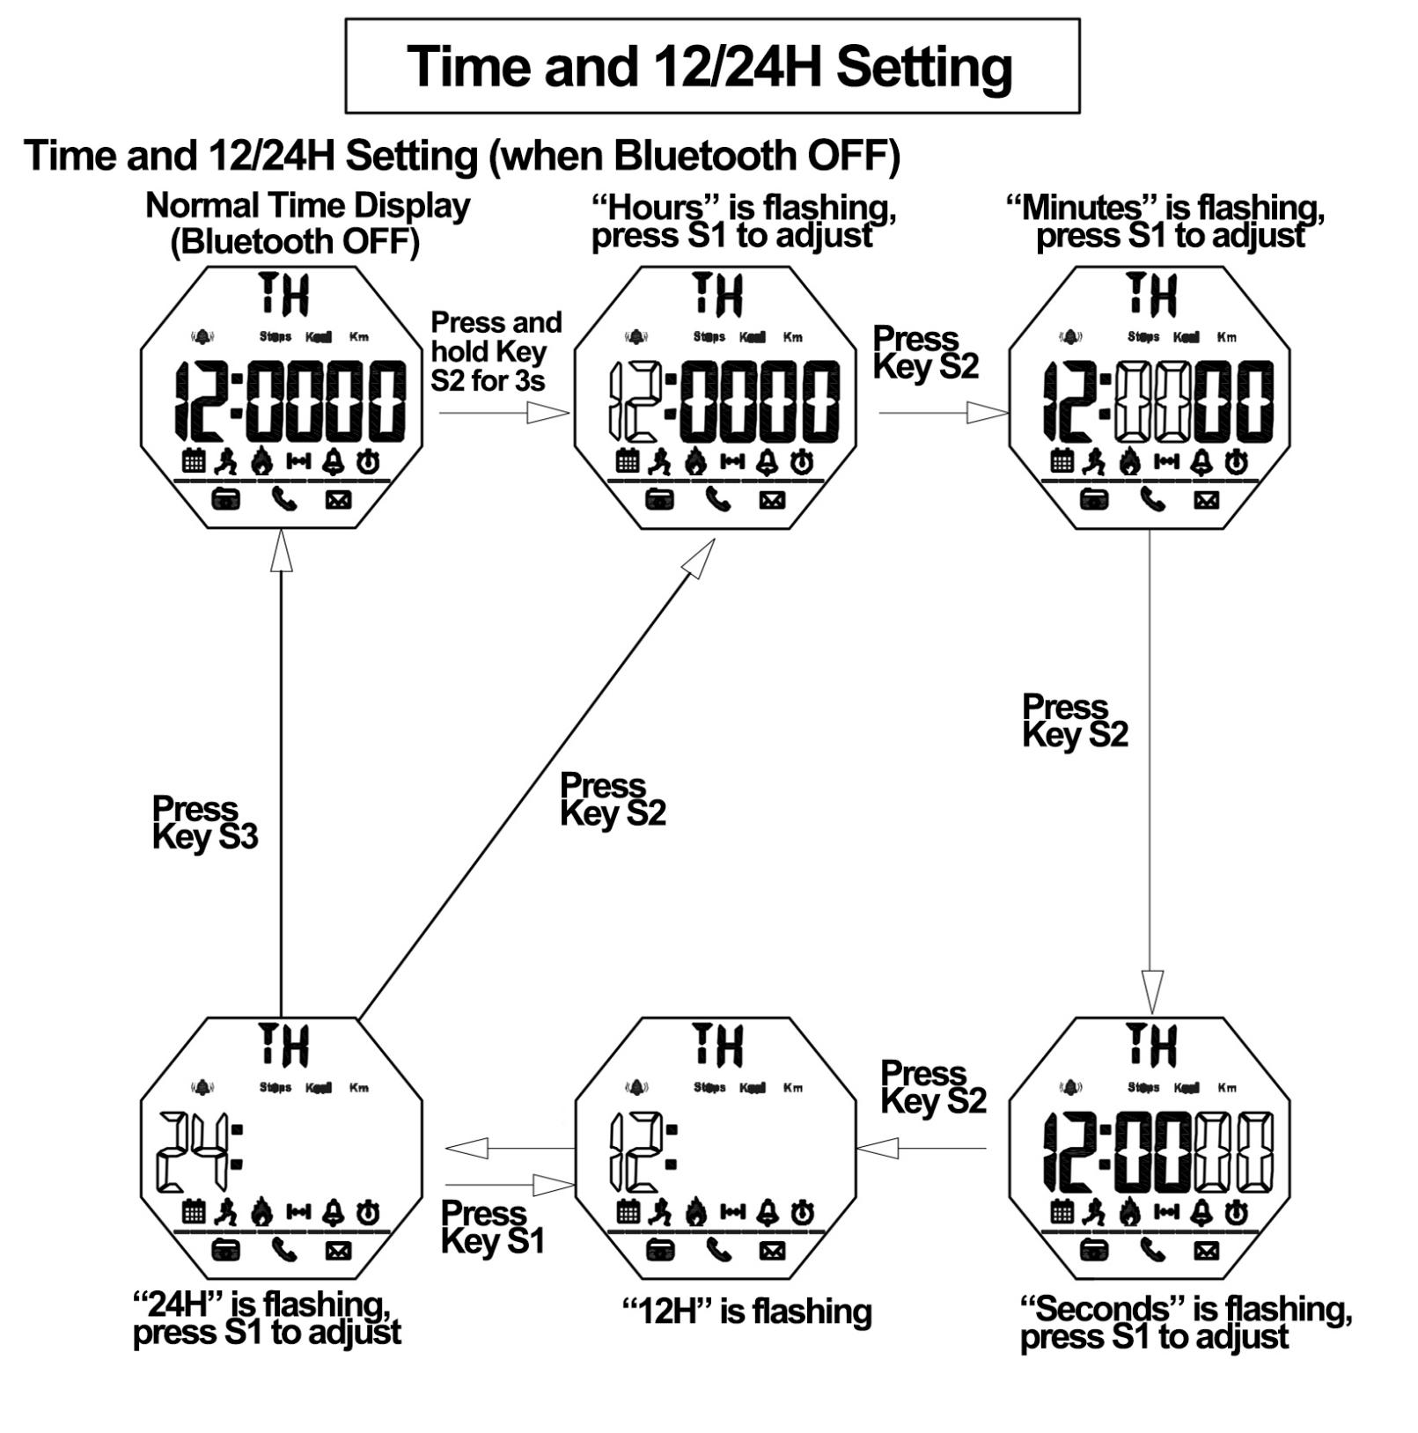

**Remarks**

**1.** In any setting mode of time and 12/24H, press Key S3 to save the current setting and return to Normal Time Display (Bluetooth OFF)

**2.** In any setting mode, it will return to the Normal Time Display automatically if without any operation more than 10s.

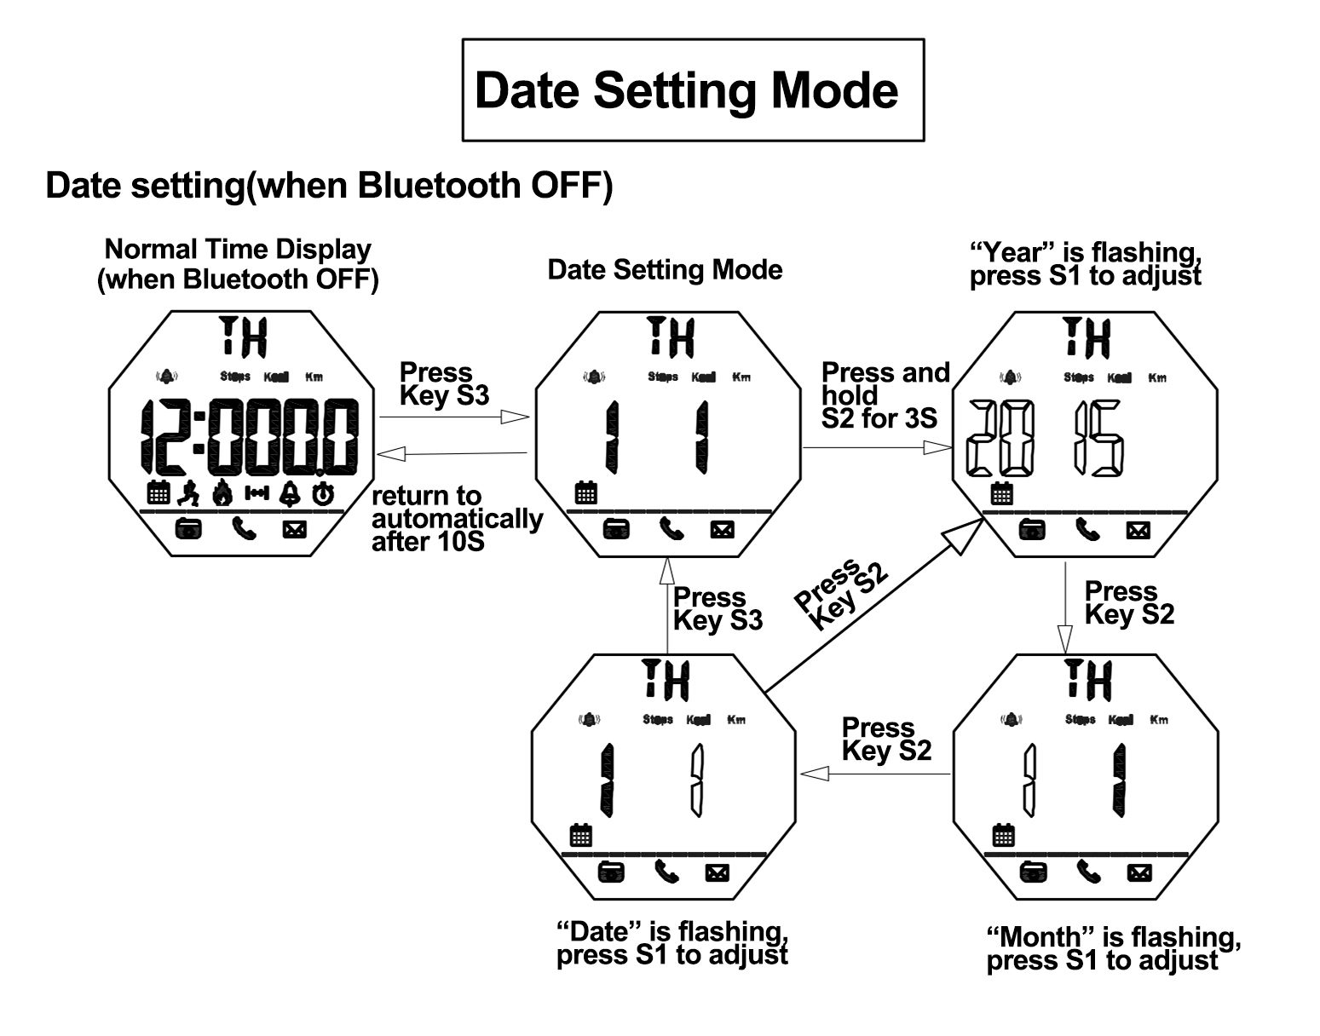

**Remarks**  
1. Calendar range : 2000~2049

**2.** In any setting mode, it will return to the Normal Time Display automatically if without any operation more than 10s.

**3.**In any setting mode, press S3 to save the current setting and return to the previous menu.



**When the battery voltage is lower than 2.4V, low battery icon will be flash to remind the user to change the battery**

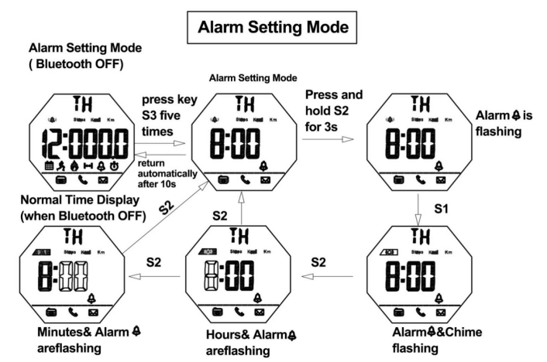

**Remarks**

When reach to preset alarm time, it will beep for 6s.

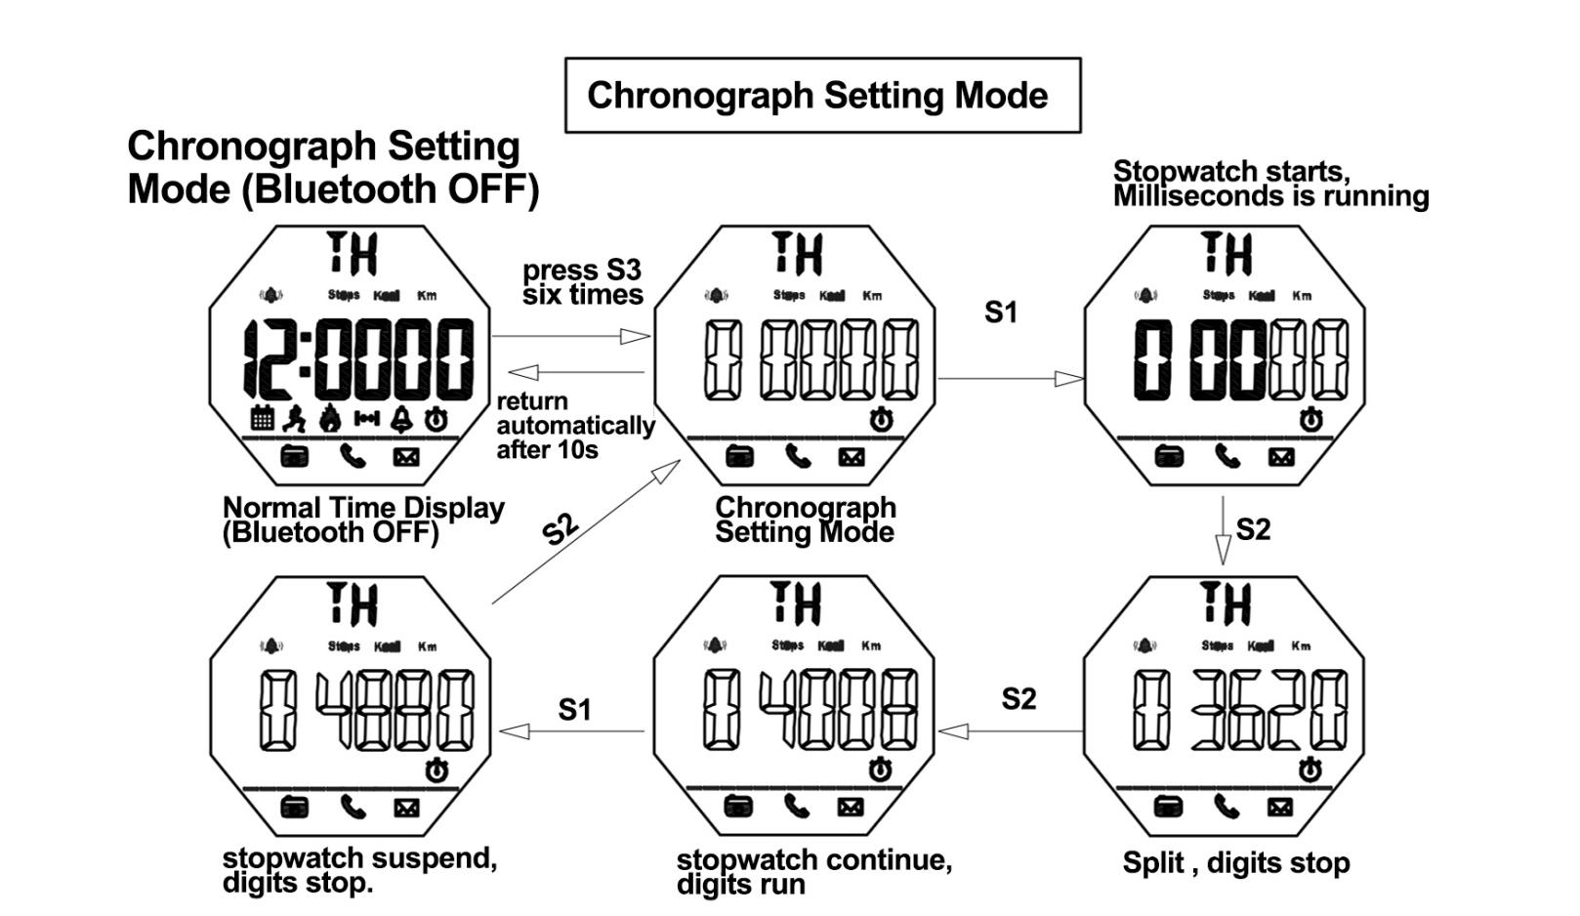

**Remarks**

1. The maximum chronograph time is 59”59’59
2. If the record runs up to the maximum, the stop watch will start recording from zero again.
3. If the stop watch is running and hasn’t been reset, while switch to other function mode, the stopwatch will run continually in backstage.

**How to check the current date sport data**

**In the BlueTooth OFF status to check the current date sport data**

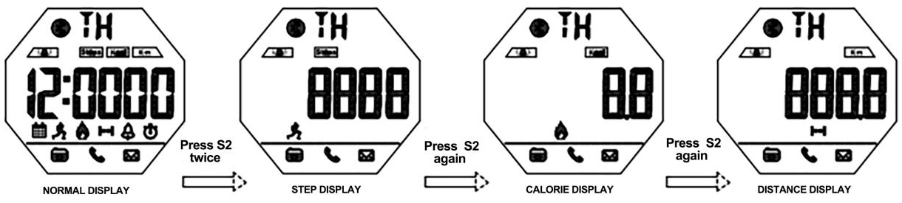

**REMARKS**

Current Date Means every day 0:00 am-23:59pm

The 24H pedometer function ON by default when the watch boot and the first 10 steps generally can not be detection，which will be allowed for deviation, not record in the pedometer device.

**How to download the APP and install in the phone**

1. **IOS phone APP download and install**

PHONE/IPAD scan QR CODE of following P6 or search keyword “Sports+ by Guanghui”( leave a blank space following “+”) on APP Store and you will see the interface as following P1, then download & install the APP, Click the Sports+ icon which show as following P2 to open the APP, the phone will remind the user to turn on the bluetooth function If the mobile bluetooth function OFF to allow the Sports+ to connect the APP which show as following P3.

**2.Android phone APP download and install**

1) Android mobile phone(Foreign Users)scan the QR CODE of following P7 or search keyword “SportPlus” on Google PLAY to download and install the APP, click the Sports+ icon to open the APP. the phone will remind the user to turn on the bluetooth function If the mobile bluetooth function OFF to allow the Sports+ icon to connect the APP.

1. Android mobile phone(China Domestic Users) scan the QR CODE of following P8 or search keyword “SportPlus”on Application of treasure to download and install the APP as P4,click the Sport+ icon to open the APP. The phone will remind the user to turn on the bluetooth function If the mobile bluetooth function OFF to allow the SportPlus to connect the APP. Or search”sports+” on 360 Mobile Assistant to download and install the APP as P5.

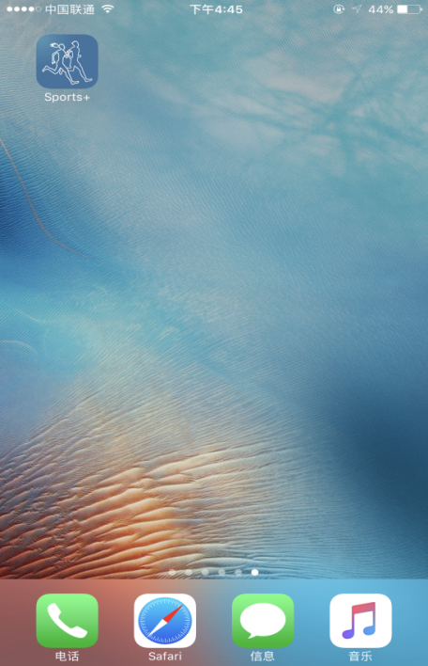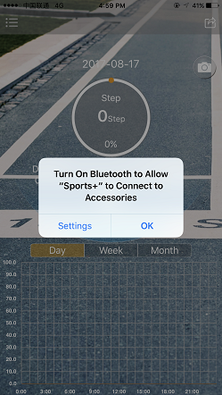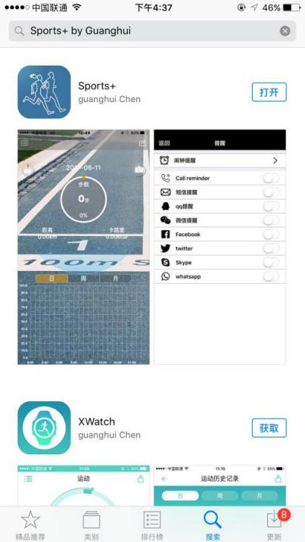

P1.:IOS mobile phone interface

(search and download the Sports + by Guanghui” )

P3.:IOS mobile phone interface，

Reminds turn on the

bluetooth connection

P2.:Click“Sports +”on IOS

mobile phone interface

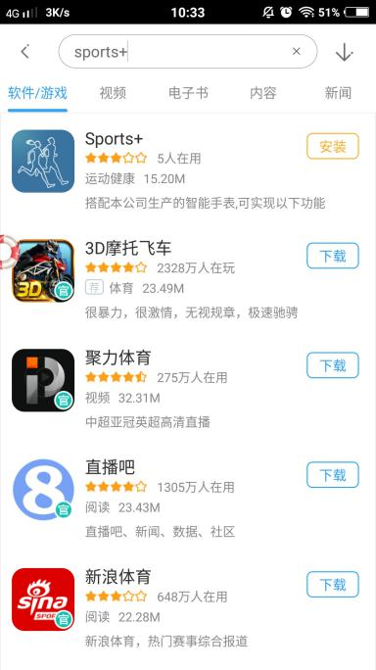

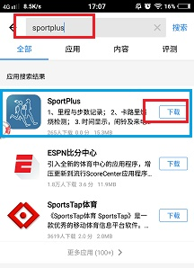

P5: Android mobile phone interface (360 Mobile Assistant search and download “SportPlus”)

P4: Android mobile phone interface (Application of treasure: search and download “SportPlus”)



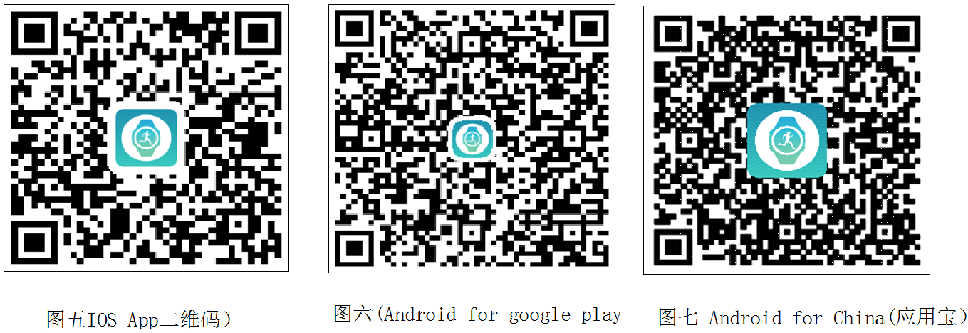

P8.: Android for China

(Application of treasure）

P7: Android for Google PLAY

P6.: IOS APP QR CODE

**3.Android mobile phone app download and install:**

Click “Allow” to allow install and then click "Install" to carry on installing, click “Done" to finish installing, click “open” to open the app.

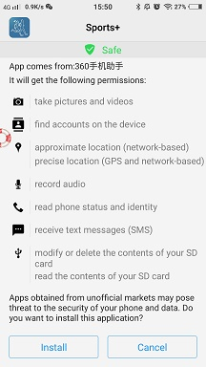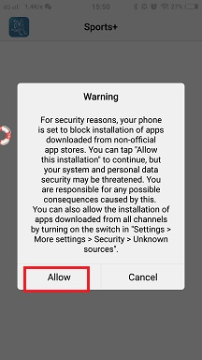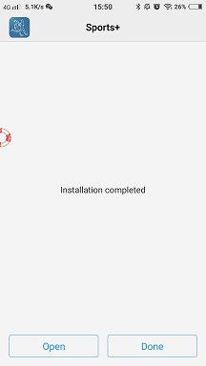

3. Click “Done”

2. Click “Install”

1.Click “Allow”

**Mobile APP Operation**

1. Click the Sports+ icon to enter into the app. For the new user, click the menu on the top left corner to enter into setting interface. Click the avatar box to set personal information.

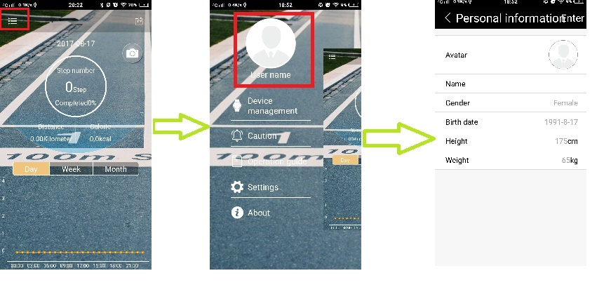

3. Setting personal information

2. Click the avatar box

1. Click the menu on the top left corner left upper

Set your target brithday

体重设置

Set your target weight

**Bluetooth Connection And Binding**

Turn on the bluetooth both on mobile phone and Sports+ before using bluetooth to connection and binding them. Open the APP then click the menu on the top left corner to enter into the setting interface, selecting "Device management”→ "Binding the new device”,searching around Sports+ and connecting →Matching the Sports+.

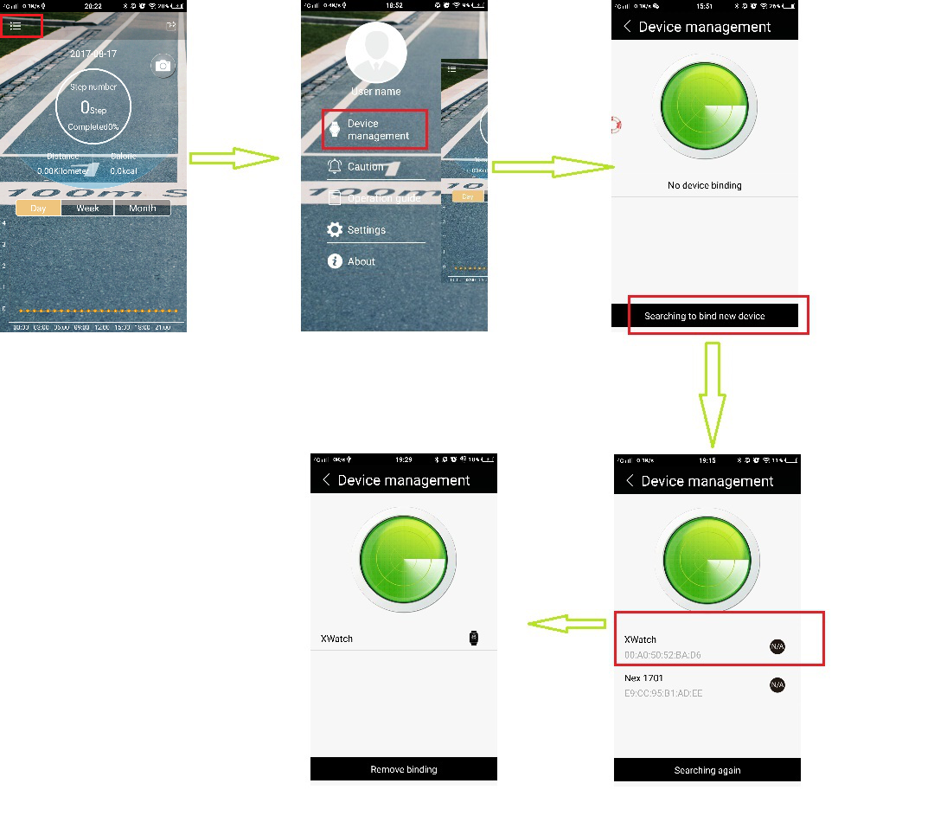

5. Connected

4. Select the XWatch

3. Click Searching to bind new device

2. Click Device management

1. Click the menu on the top left corner left upper

**Remarks:** The android mobile operating system must be or Above android version 4.3. The android mobile bluetooth must be above 4.0 version; The apple mobile phone must be or above IPHONE 4S versions.

**Data sharing after Bluetooth Connectivity**

Click “sharing” icon to start sharing. Data can be shared to QQ, WeChat, Facebook and Twitter.

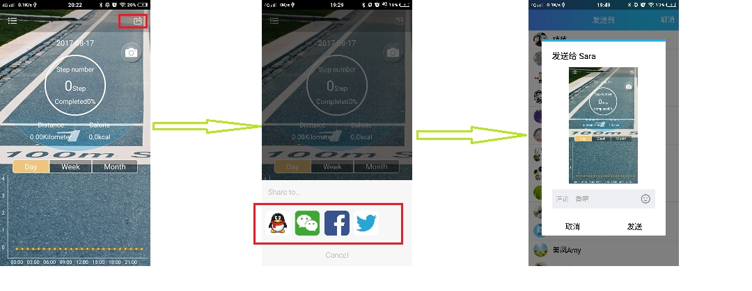

3. Sharing

2. Select Apps

1. Click “sharing” icon

**Data synchronization After Bluetooth connect**

**1. Time synchronization: Time will be synchronized when connect with Phone successfully .**

**2. Swipe down to refresh the data of sports : Sport Steps、mileage.、Calories Consumed.**

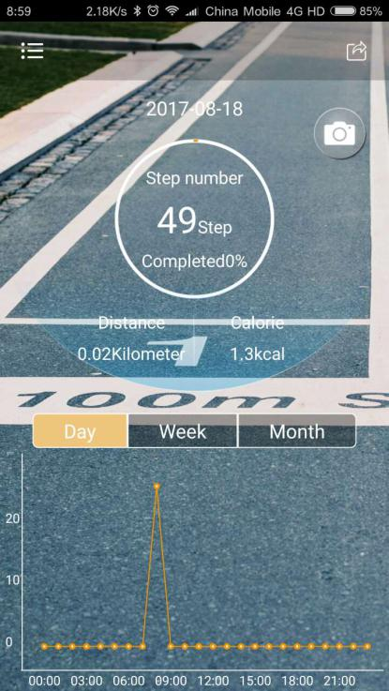

Curve is to view historical data , historical data is 15minutes to refresh once

Real time data

Slide up and down hours and minutes to the scheduled time and then click “confirm”

1. **Alarm Setting :**

Try one of the other

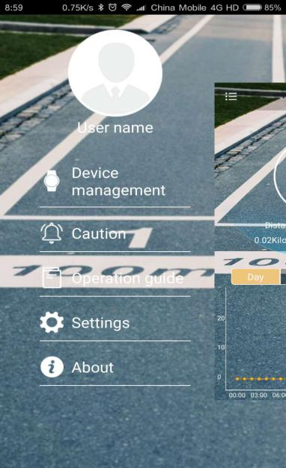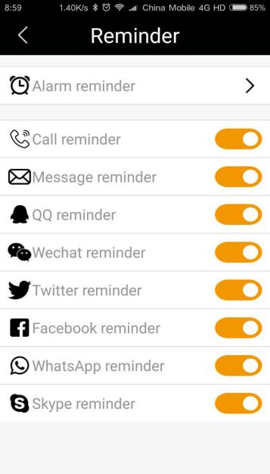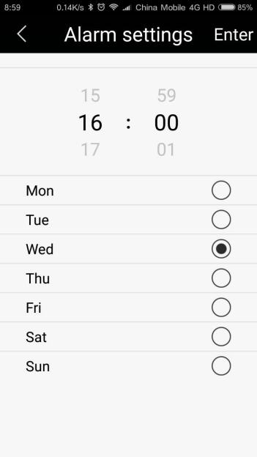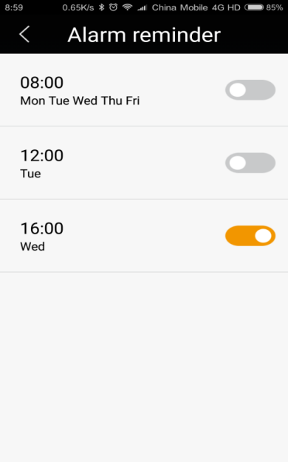

Click “reminder”

Repeat above operation and set up other two alarms

**5. Reminding Setting**

1) Call Reminding,: Turn on the Bluetooth of watch in Normal time display mode

2) Messages Reminding setting : Turn on all the reminding function on APP such as SMS .QQ . WECHAT . TWITTER. FACEBOOK. WHATS APP .SKYPE

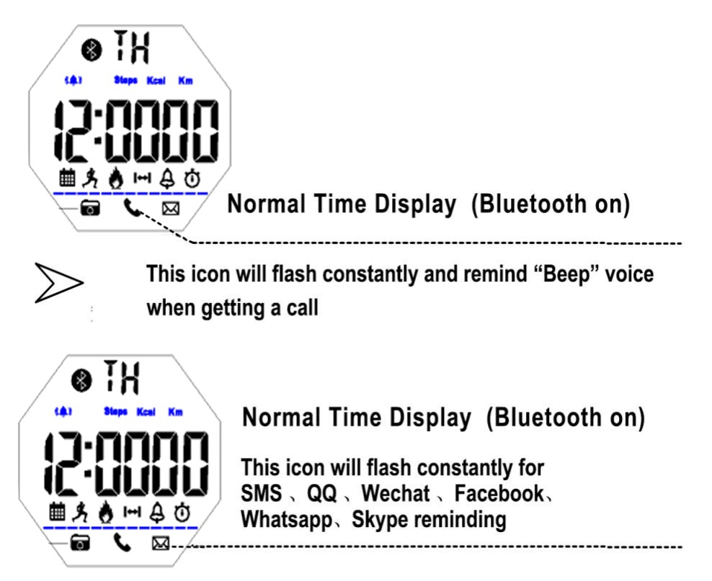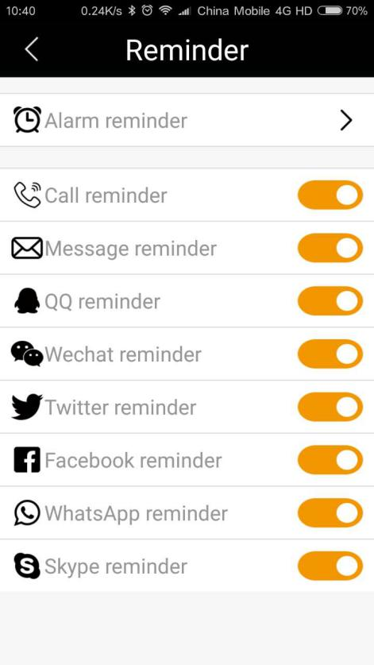

Open all reminder function

**Remarks :**

1) The watch will make “Beep”voice for 6 seconds after setting up alarm time on APP .

2.)The watch will make “Beep”voice for 12 seconds to remind When open all permissions and turn on the reminding of Call 、SMS、QQ 、WECHAT、TWITTER FACEBOOK、WHATSAPP、SKYPE ,

**6: Remoting phone camera:**

After connect the watch with phone via Bluetooth.

Turn on camera firstly on the phone, then press S1 key on watches to remote phone camera.

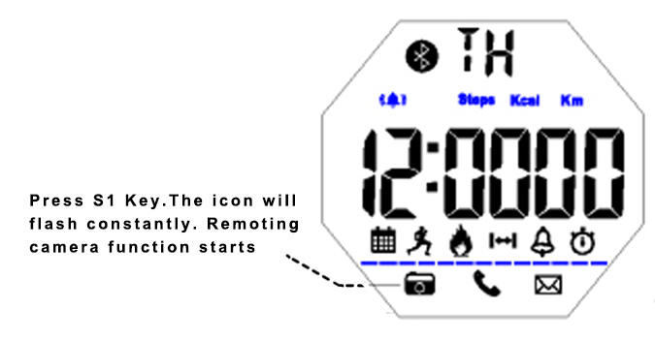 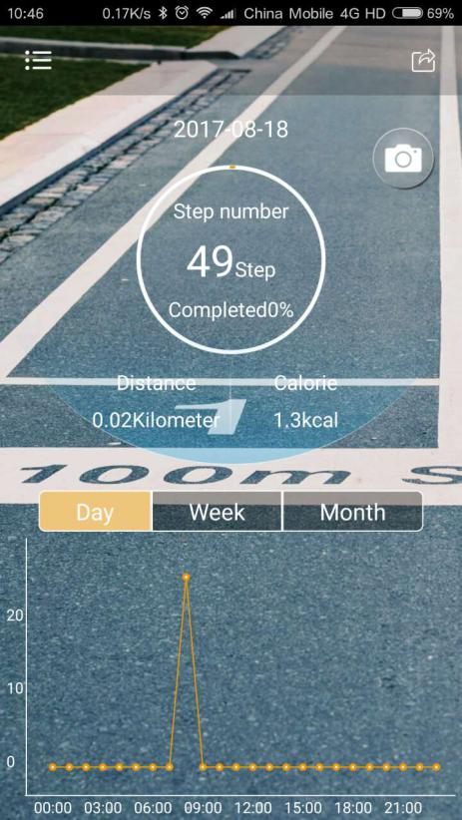

Click camera signal

Normal time display(Bluetooth on)

**Notice**:

Some android phones can not connect bluetooth data and notifications in the background,i.e. Huawei X4,please find the **Notification Center** in the **Settings** ,let the Wechat,QQ and Sport+ be allowed ,open them in **Protected apps**.Find QQ,Wechat and Sport+ from **Applications** of **Permission manager**,and choose to T**rust this application** of them as follows:

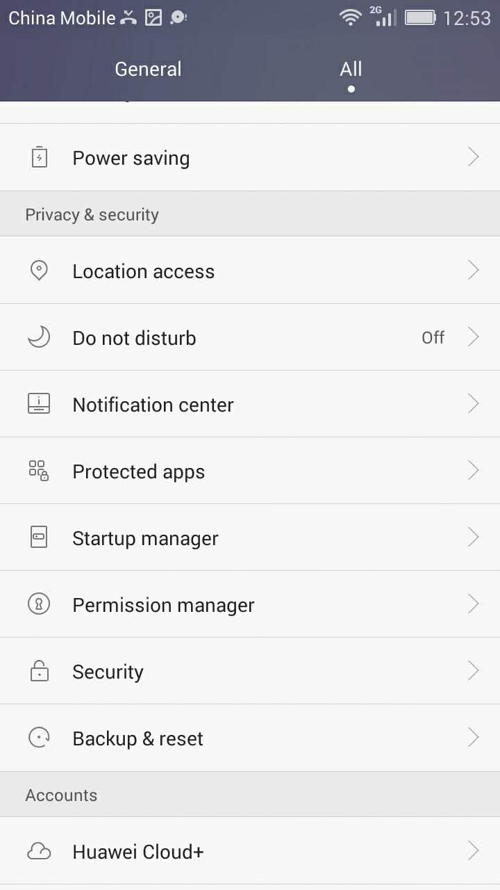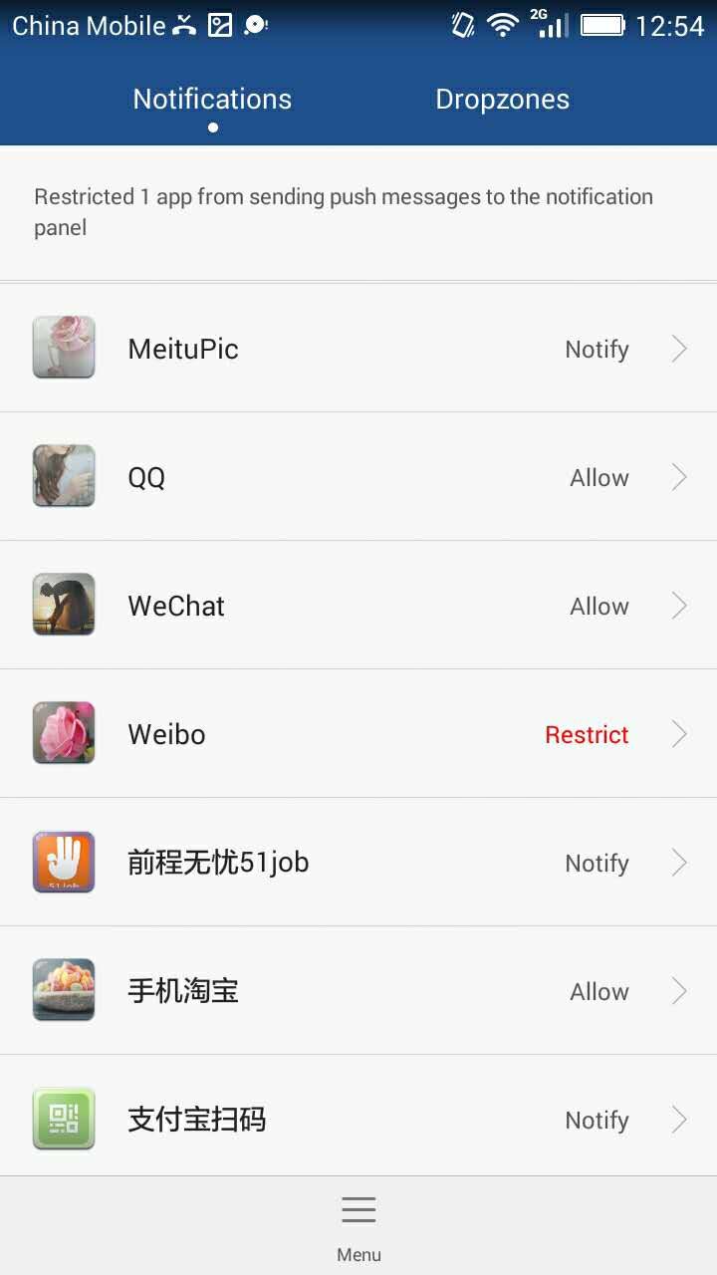

1. Click Notification apps 2. Click Allow

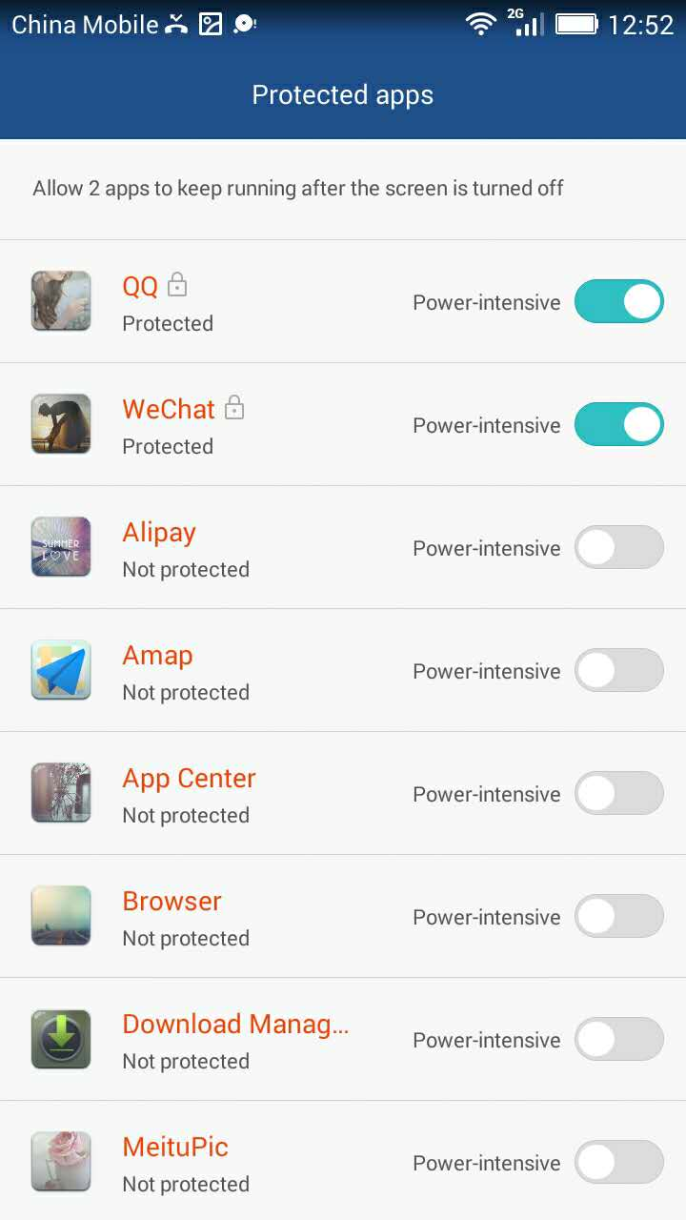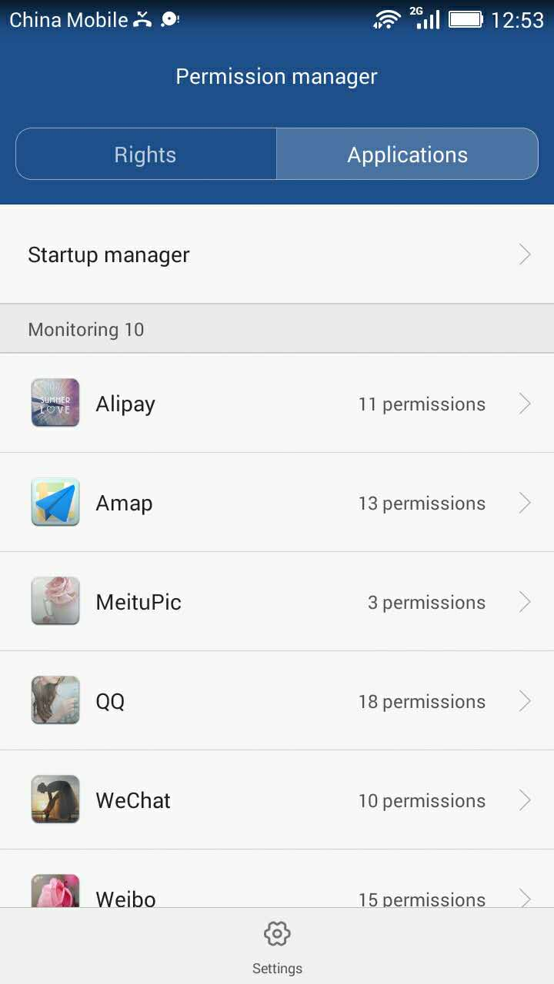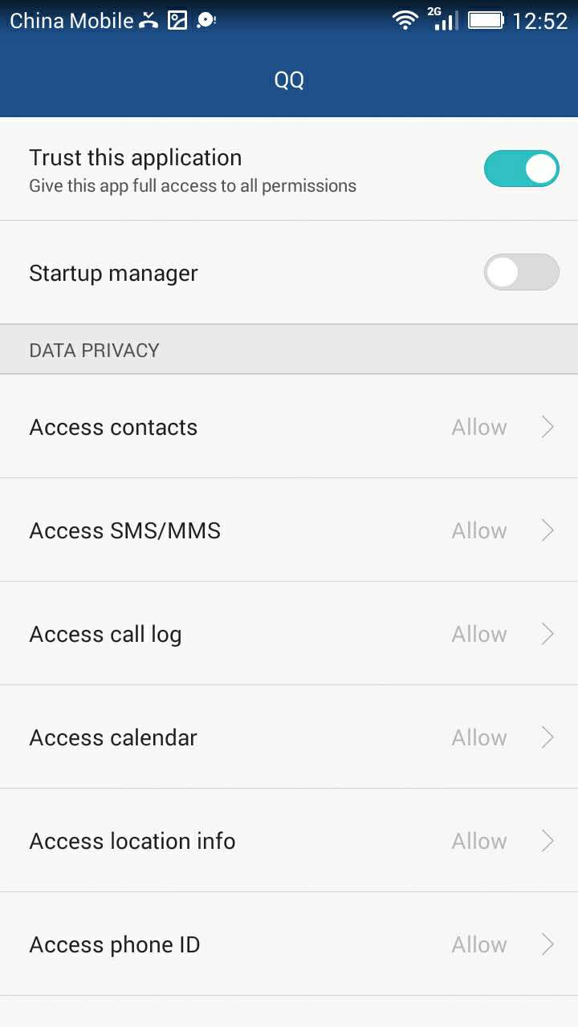

3. open the power-intensive 4. find them in the Application 5. open the Trust this application

**There have Two steps to unbind the Sport+ with IOS phone:**

1.disconnect the app between Sport+ with IOS phone;

2.disconnect the bluetooth between Sport+ with IOS phone. i.e. iphone 6 as follow:

Firstly unbind the APP on the Sport+(it means exit the APP),

Meanwhile find the Sport+ from the Bluetooth in the phone Settings function,then Click the “i” to Unpair the Sport+

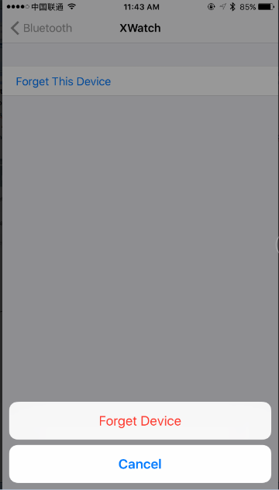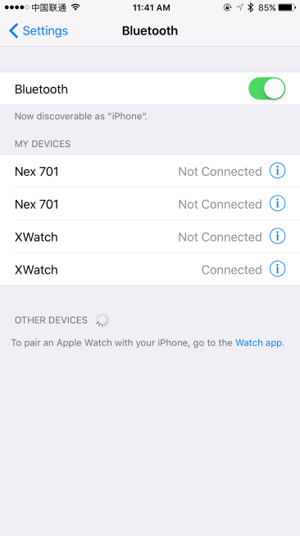

In the phone’s “settings” “Bluetooth”drop-down list to find “Sport+ ”click “connected”behind the “i”

Then click “ignore the device”

|  |
| --- |
| **Electrical Parameters** |

|  |  |  |
| --- | --- | --- |
| 1 | Operating Voltage | 3.0V |
| 2 | Wireless connection distance | ≥8 (Open environment) |
| 3 | RF Working frequency | 2402-2480MHz |
| 4 | Battery Code | CR2430(290mAH) |
| 5 | Shutdown current | ≤0.15uA |
| 6 | Walking current (Bluetooth connect ,phone move) | 0.076 uA |
| 7 | Static current(pedometer ON, bluetooth OFF) | ≤40uA |
| 8 | Phonate current | ≤5.7uA |
| 9 | light current | ≤15uA |
| 10 | Average current of chrono | ≤0.46uA |
| 11 | Update data current | ≤0.65uA |

**Battery Life**

|  |  |  |
| --- | --- | --- |
| MODE | Daily using description |  |
| High Consumption Mode | Pedometer 24h online,cumulative bluetooh connecting 12h, Alarm18s/time, EL back light 2time4s, Calls&SMS alerts 40times. | ≥5months |
| Standard Mode | Pedometer 24h online, cumulative bluetooh connecting 2h, Calls&SMS alerts 10times. , Alarm18s/time, EL back light 2 times 4s. | ≥6months |
| Saving Mode | Pedometer 24h online, every 2 week synchronize motion data 0.5 hours, Alarm18s/time, EL back light 1 time 2s, close calls &SMS alert function. | ≥9months |